Chapter 1: Sec 1.1, 1.2, 1.3, 1.4

Chapter 4: Sec 4.1, 4.2

4.1就是induction

Chapter 8: Sec 8.1, 8.2

Chapter 9: Sec 9.1, 9.2, 9.3, 9.4

Chapter 10: Sec 10.4

先看教材+assignment

再看tutorial

再看手机题目

combinatorial proof,

counting,

induction proof,

generating functions (not sure about the last one)

inclusion & exclusion & recurrence

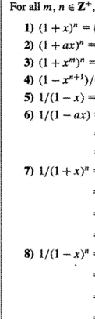

123都是展开变种

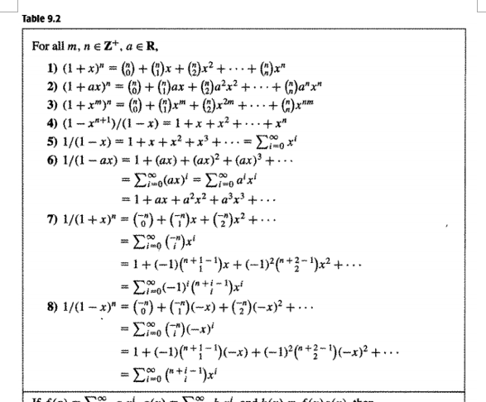

NC0 NC1 NC2 NC3 NC4 NC5

NC0 ANC1 A2NC2 A3NC3 A4NC4 A5NC5

1+xmnc1 +x2m nc2 +x3m nc3,,,

1+x+x^2+x^3.....

1+x+x^2+x&3....

45一样，而且很重要

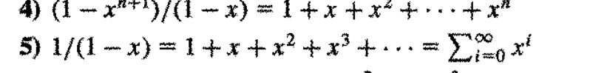

45区别在于4是有限的

1+x+x^2+x^3+x^4+x^5

只能转化成1-x^6/1-x

1-ax = 1+ax+a^2x^2..... 6是5变种

n是固定数，i是变动数，i是item总数

(-1)^i (n-1+i,i)x^i

n-1+i,i

10 .4乘xn最大项，累加转成general function左边，常数general function简化

2 f(x)放一边，求出AB

f(x)简化式转出来，求出an系数

